Name _____________________________________ AP Calculus
Part 1: No Calculator Allowed Chapter 3 Review

Show all your work!

1. If $f(x)=x^{4}+3x−1$, find $f'(2)$.

2. If $y=(x^{5}−2)^{2}$, then $\frac{\text{dy}}{\text{dx}}=$

3. If $f(x)=\text{cos}(\text{ln}x)$, then $f'(x)=$

4. Explain why each graph below is not differentiable at x = 0.

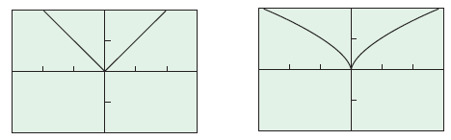

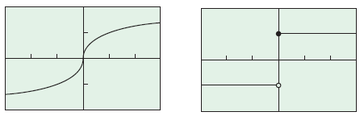

5. If $y=\frac{e^{−2x}}{2x}$, then $\frac{\text{dy}}{\text{dx}}=$

6. The $\underset{h→0}{\text{lim}}\frac{\text{sec}4(x+h)−\text{sec}4x}{h}$is
7. If $f(x)={\text{cos}}^{−1}3x$, find $f'(x)$.

8. Find the slope of the tangent to the curve $x^{2}−2\text{xy}+3y^{2}=8$ at the point (3, 4).
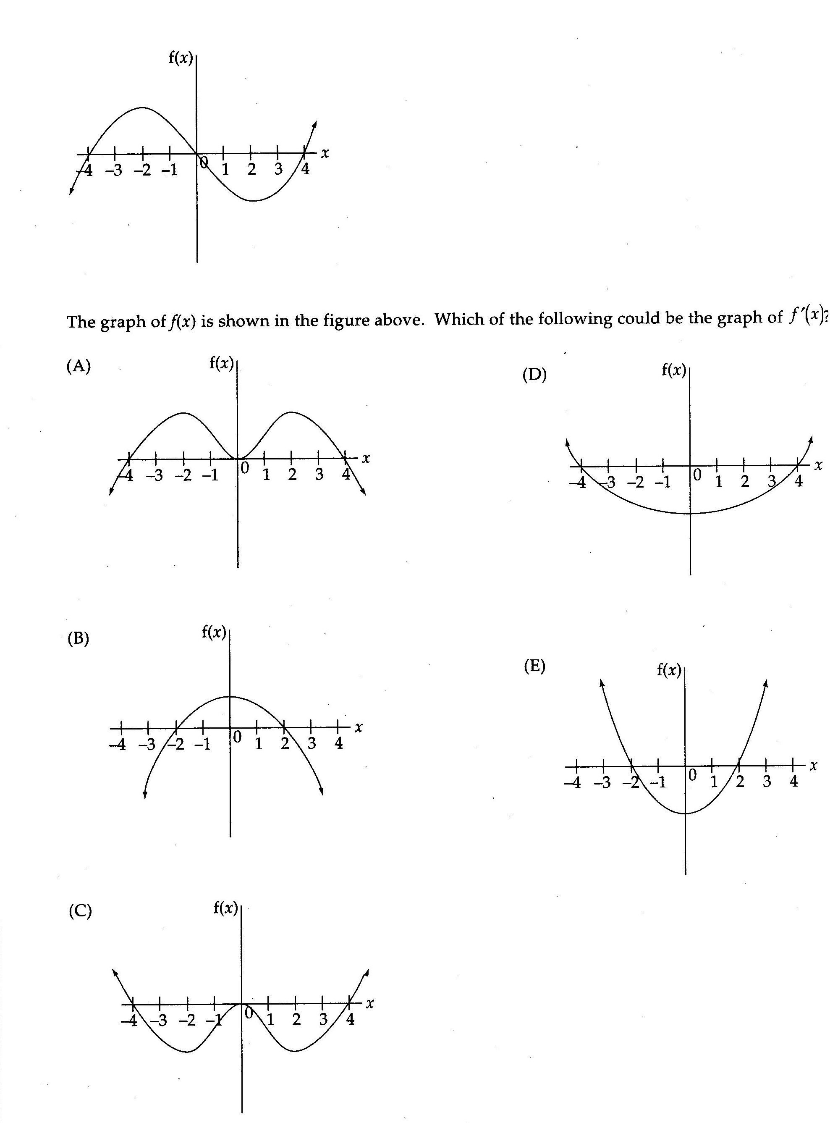
9.
Name _____________________________________ AP Calculus
Part 2: Graphing Calculator Required Chapter 3 Review

Show all your work!

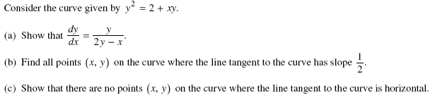
10.

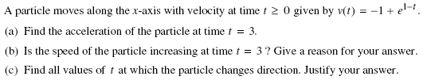
11.

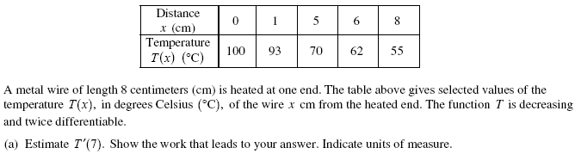
12.

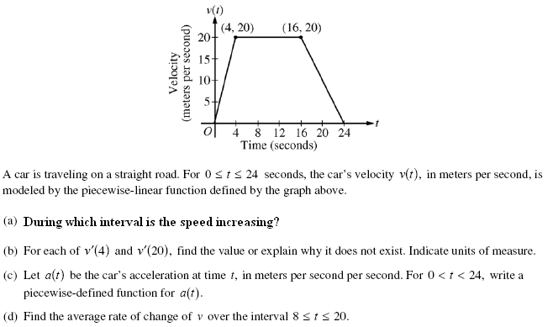
13.

